Методические рекомендации
по подготовке учащихся к диагностическим работам по иностранному языку
в 5 классе
Авторы: Чекерда Е.А., Селезнева С.Ф., Сирош О.Н.
Диагностические работы по иностранным языкам для всех уровней образования обязательно включают задания, позволяющие оценить уровень сформированности навыка смыслового чтения. Именно на этот вид деятельности стоит обратить особое внимание. Безусловно, для успешного выполнения заданий раздела «Чтение» у обучающихся должны быть сформированы на достаточном уровне языковая и речевая компетенции. Но важную роль также играют и метапредметные умения.
Работа по обучению смысловому чтению должна быть подчинена единой системе работы с текстовой информацией в образовательной организации. Важно отметить, что не только учителя русского и иностранных языков несут ответственность за качество работы, т.е.учителям разных предметов необходимо согласовывать действия. в данном направлении. В настоящих методических рекомендациях обратим внимание как на стратегии смыслового чтения, так и на специфику работы учителей иностранных языков в данном направлении.
Работа с текстом состоит из 3 этапов: до чтения, во время чтения и после чтения.
Вне зависимости от содержания и типа задания, учащиеся должны помнить, что до чтения необходимо внимательно изучить инструкцию с формулировкой задачи и объяснением формата, в котором должен быть представлен результат. Важной составляющей инструкции является образец выполнения задания. Работая с инструкцией на иностранном языке, у учащихся могут возникнуть трудности языкового характера. В этом случае образец играет особую роль. Следует приучать учащихся не пренебрегать этим важным этапом выполнения работы.
Ознакомившись с заданием, учащиеся должны уметь определить цель предстоящего чтения: усвоить основное содержание и основную мысль, извлечь запрашиваемую информацию или понять текст детально и осуществить его интерпретацию. Осознание цели помогает определить дальнейшую стратегию работы с текстом.
При необходимости понять основное содержание и/или извлечь необходимую информацию важным метапредметным умением является умение выделить ключевые слова. Умение воспользоваться языковой догадкой с опорой на контекст поможет компенсировать недостаточный словарный запас.
При необходимости детального понимания иноязычного текста требуется высокий уровень языковой компетенции. Говоря о метапредметных умениях, важно понимать, что должно быть сформировано умение интерпретировать текст.
Разработчики диагностических работ в соответствии с требованиями Примерной образовательной программы включают тексты разных стилей и жанров, предлагая задания разных форматов, преимущественно тестового характера. Особое место занимает графически оформленная информация и ее переработка в личностно-смысловые установки в соответствии с коммуникативно-познавательной задачей.
В качестве примеров приводим образцы заданий на смысловое чтение для 5-6 классов базового и повышенного уровня трудности. Материалы взяты из УМК «Spotlight» и метапредметной олимпиады, разработанной в АППО в 2017 году.

Match the jobs to the daily routine. One title is extra.
- BUSINESSMAN
- SINGER
- PRESIDENT
- SPORTSMAN
- JOURNALIST
- He gets up at 7:00 in the morning and goes jogging. Then he has a cold water shower and a healthy breakfast. After that he goes to the gym to play basketball. Then he lifts weights and runs. He is very strong. At half past two he has lunch with his family. He plays with his children after lunch. And at four o’clock he trains again. At night, he eats dinner with his family and watches TV. He goes to bed at 10:00.
- The alarm clock goes off at 5:00, and he jumps in the shower. His office is 5 minutes away. And he has to be at his desk, at his office, with the first cup of coffee and write the first word at 5:30, five days a week. His goal: to write a page every day. Then he goes to court to collect and report information. During the daytime he takes some interviews.
- From Monday to Friday she wakes up early, at seven o’clock, because at 8 o’clock they start recording “Tosca”. At two o’clock she has lunch in a restaurant and in the afternoon she goes to the café and meets her friends. Then, she works with composer or her teacher. If she is free she goes shopping or to the cinema. In the evening she starts studying the text.
- He starts his day with morning exercises at 6:45, reads several newspapers, has breakfast with his family, and then starts his work just before 9:00.His day is usually packed with meetings, speeches and public ceremonies. The activities may include: making phone calls to other heads of state, meeting with members of Congress, discussing policy with advisors and staff, speaking with the media.
A | B | C | D

Read the email and mark the sentences T (true) or F (false)
Dear Mark,
How are you? I’m fine. I’ve got a great cap collection. I’ve got twelve caps. They are from the UK, the USA, Australia, France, Japan and Canada. My Australian cad is a present from my friend Steve. I’m proud of my collection. Cap collecting is fun and easy. It makes me happy.
Best wishes,
Damien

0 | The email is about Damien’s cap collection. | T
1 | The email is from Mark.
2 | Damien likes his cap collection.
3 | He has got 13 caps in his collection.
4 | The cap from Australia is a present from his dad.
5 | Damien is proud of his collection.
6 | Cap collecting isn’t easy.

Read the text and give a short answer to the questions.

This is a picture of a penguin. A penguin is a bird. Penguins can’t fly. They live in the Antarctic. Feathers help penguins stay warm in cold weather. Their size helps too. They are fat! The penguin is black and white. Penguins don’t sleep during the day. They sleep at night. They swim fast and catch food in the sea. They eat small fish and can stay under water for five minutes.

- What is a penguin?
A bird.

1. Where do penguins live?
___________________________________________________________________________

2. What helps them to stay warm?
___________________________________________________________________________

3.What colour are penguins?
___________________________________________________________________________

4. When do penguins sleep?
___________________________________________________________________________

5. What do penguins eat?
___________________________________________________________________________

Read the text and choose the right option.
Once upon a time there was a city called Hub-Bub.
It was the noisiest city in the world. The people there never talked, they shouted. The noisiest person was a young prince. He was a very little boy, only eight, but he could make more noise than grown-up people.
His favourite game was to climb up the ladder with cans and then to knock them over with a loud crash.
One day he told the king, “I want to hear the loudest noise in the world for my birthday.” The king liked the idea. “It will be funny to hear millions of people shout “Happy Birthday” to my son”.
The day came and two billion people gathered in the city square. They looked at the Tower Clock. The young prince waited for the loudest noise looking at thousands people from his balcony. But there was absolute silence. Every person was silent. For the first time in his life he heard the singing of birds and the whisper of the wind in the leaves. He was happy.
0. This story happened
a) yesterday | b) long ago |  | c) on Monday
1. Hub-Bub was
a) a beautiful city |  | b) a little city | c) a very noisy city
2.The young prince was
a) 7 years old |  | b) 8 years old | c)grown-up
3. The young Prince liked
a) to play with people |  | b)to make noise | c)to look at people
4. The young prince asked his father as a birthday present
a) the loudest noise |  | b)a square toy | c) a funny can
5. When the birthday came
a) people were shouting |  | b) people weren’t shouting | c) people were singing
6. What did the young prince feel when there was silence.
a) he felt surprised |  | b) he was glad | c) he was angry

Прочитайте тексты и сделайте задания после него

Starfish are some of the most beautiful animals in our seas. However, starfish are slow and unintelligent. They usually have five arms, but some have as many as 44. If a starfish loses an arm, it can grow it again. Starfish cannot be eaten.
Jellyfish are also very beautiful but not intelligent. And some of them are dangerous. A jellyfish looks like an umbrella, with arms or tentacles. These will sting you if they touch you. Jellyfish are not good to eat.

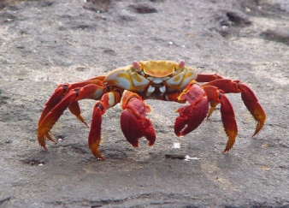
The crab has a hard shell and ten legs. If it loses a leg it can grow it again. Some are very large (more than three metres across). The crab can live in fresh water as well as sea water and some live land. Crab can be eaten.

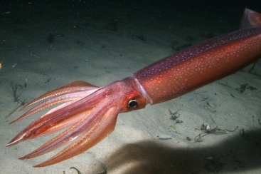
The squid does not have a shell. It does, however, have ten ‘arms’ or tentacles. Squids grow to an enormous size. In 1954 one was found in Norway that was nine meters long and weighed about tone. The squid can get away from its enemies because it is very intelligent and very fast. You can eat squid.

The octopus, which belongs to the same family as the squid, has eight arms. It has a soft body and is very intelligent. It can change colour very quickly, so its enemies can’t see it. When an enemy attacks it, the octopus releases black ‘ink’. You can eat ‘octopus in ink’ but it makes your teeth black!

Напишите «да» или «нет» в таблицу согласно информации из текстов. Не вся нужная информация есть в текстах, поэтому могут остаться пустые графы.
 | Intelligent? | Beautiful? | Arms/ tentacles? | Legs? | Shell? | Edible?
starfish | No
jellyfish
crab
squid
octopus

Посмотрите на карту, прочитайте инструкции и определите место, куда вы пришли. Напишите это место.
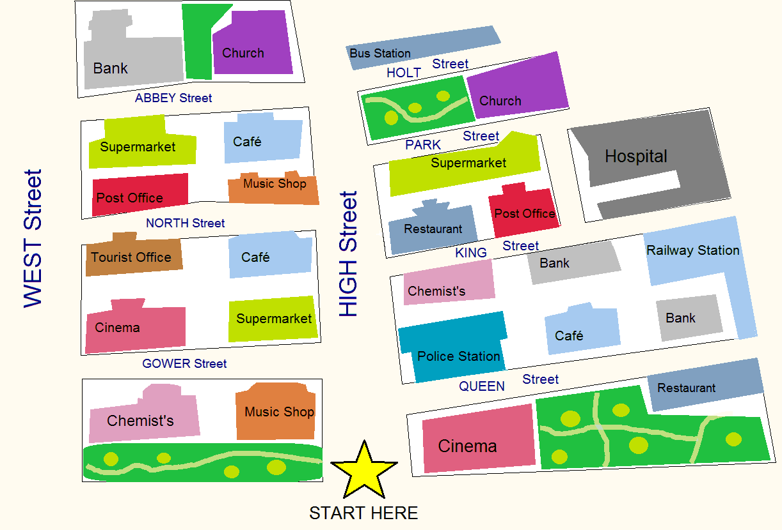
- Go straight ahead. Take the first right. Go to the end of Queen Street. It’s opposite the bank.
……………………………
- Go straight ahead. Take the second left. Walk about 100 meters. It’s next to the music shop.
…………………………………
- Go straight ahead. Take the third right. Go past the park. It’s on your left.
………………………………………..
- Go straight ahead. Take the first left. Go to the end of the street. It’s on the corner of West Street – opposite the chemist’s.
…………………………………………
- Go straight ahead. Take the third left. It’s at the end of the street – on the right, opposite the supermarket.
………………………………………..
- Go straight ahead. Take the second right. Go past the bank. Turn left. It’s on your right.
……………………………………..

Напишите инструкцию, как дойти до этого места.

- The restaurant in King Street:

- The railway station:

Прочитай приглашение и e-mail. Заполни таблицу Луизы информацией о предстоящей вечеринке.
Come to an ice-skating party
on Saturday
at
Park Ice Rink
Starts at 1.30 p.m.

You won’t need any money but bring a warm sweater.
Let me know if you can come by Thursday.
Sara
From: Carla
To: Lousia
14, February, Tuesday

Shall we go to Sara’s ice-skating party together? My dad will take us in the car but we’ll need to come back by bus. We’ll drive to yours and get you at 12.30. Ring me this afternoon on my mobile(0781621285) or after 6 p.m. at home (366387) to let me know.

Louisa’s Notes Ice-skating party
Day:
1

Time:
2 | p.m

Take:
3

Travel there by:
4

Carla’s evening phone number :
5
Place:
6

